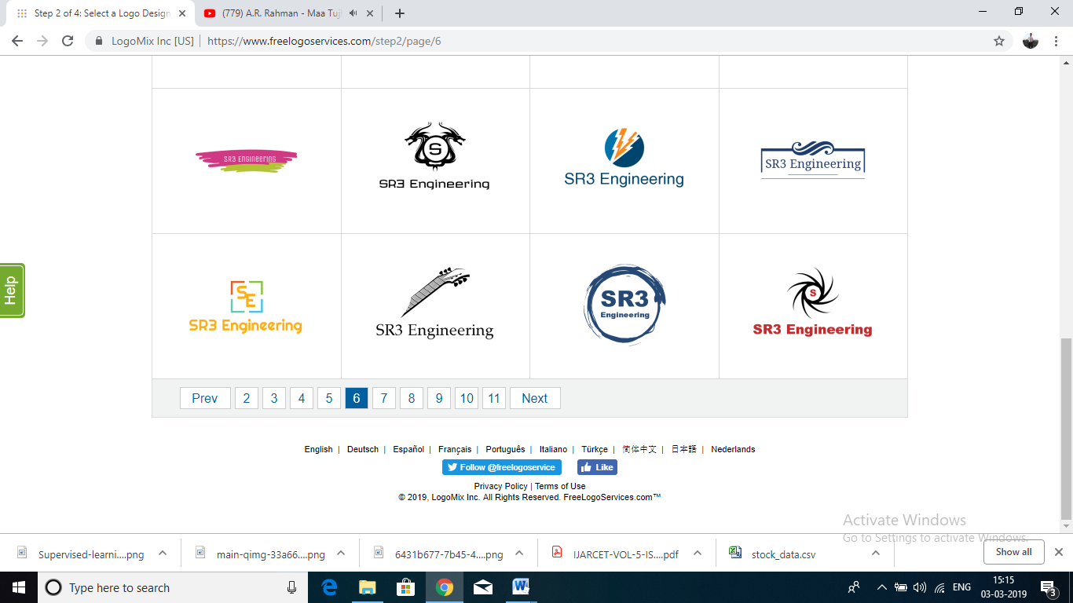**As per Syllabus of**

**SAVITRIBAI PHULE PUNE UNIVERSITY**

**BIG DATA &**

**DATA ANALYTICS**

**Semester VIII**

**Computer Engineering**

**Mr. Shyam P. Ambilkar**

Department of Computer Engineering (student)

Imperial College of Engineering & Research, Pune

Maharashtra, India